Fuhai Met Mast O&M record 2022
In order for the Met Mast to operate normally, maintenance operations need to be performed regularly. Maintenance work is divided into three major categories: above-water structure maintenance, underwater structure maintenance, and instrument and power system maintenance.

October 2022
This trip to the Fuhai Meteorological Tower is the key operation this year. It mainly involves dismantling and installing the wind speed anemometers located at 30m, 50m and 86m above the sea level, as well as replacing them.

Flight warning lights at a height of 86m.
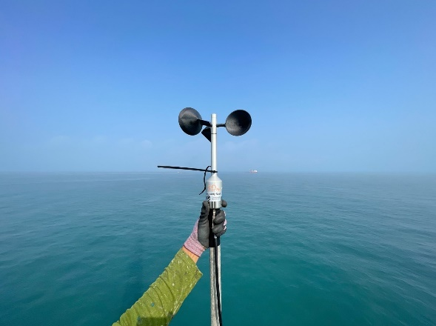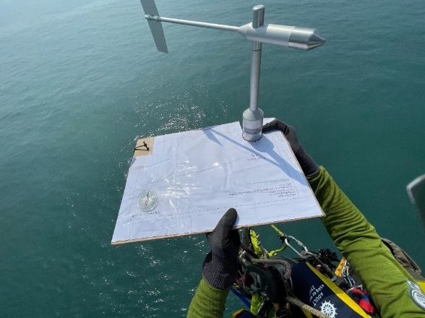
The wind direction and anemometer is installed at an altitude of 30m; the wind direction meter must be installed to ensure that it faces due north. The picture on the right shows the technician using DIY tools to determine the direction of due north.

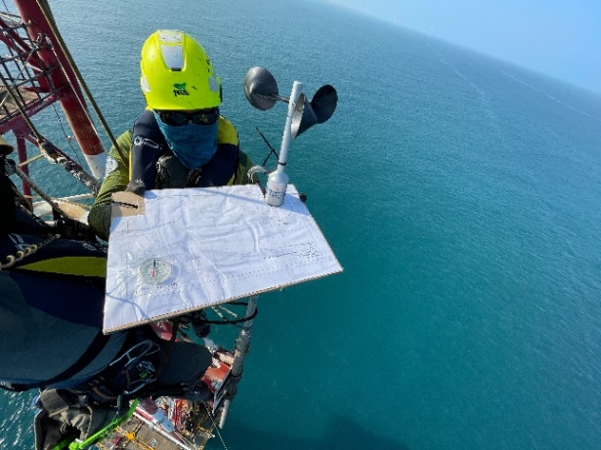

The operating procedures for elevations 50m and 86m are the same as those for 30m.
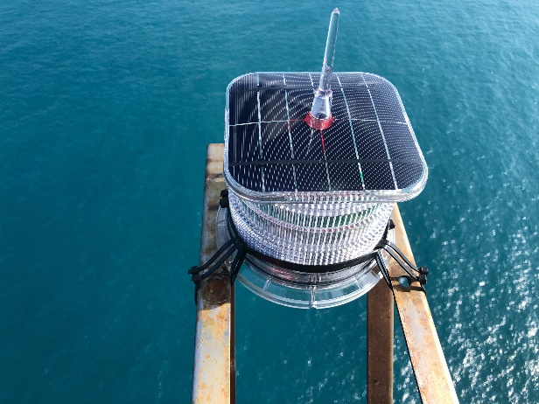
Flight warning light at 86m

September 2022
Continuing the last overseas operation, the main focus will be to replace the faulty solar charge controller and test whether it can charge normally. We will also prepare for the next anemometer replacement trip.

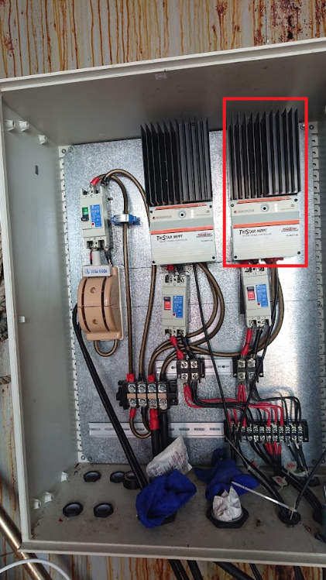
After the charge controller was replaced, it was tested to function normally.

August 2022
The work of this trip is to install communication antennas, restore the communication between the shore base and the sea weather tower, and be able to remotely monitor the charging status of the solar panels and receive wind energy data after the subsequent wind speed and anemometer replacement is completed.

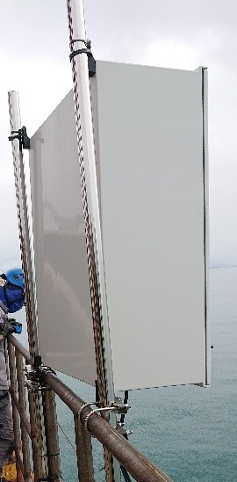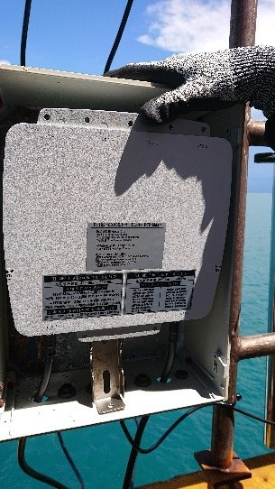
Communication antenna waterproof box / signal box

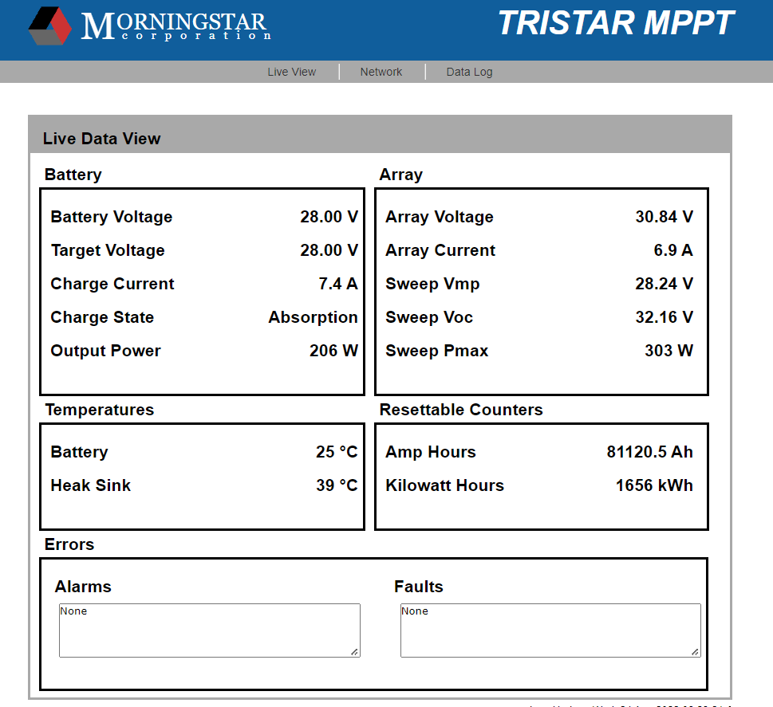
After the antenna is installed, conduct a remote connection test; the charging status of the solar panel is successfully monitored.

July 2022
The battery connection of the energy storage system was completed, but during the inspection, it was found that some of the connectors of some solar cables were corroded. It was also found that one of the solar chargers had a malfunction in measuring the voltage, resulting in the inability to charge and discharge the battery normally. The team During this operation, the solar connectors and cables were replaced. It is expected that the faulty solar charger will be replaced during the next operation.
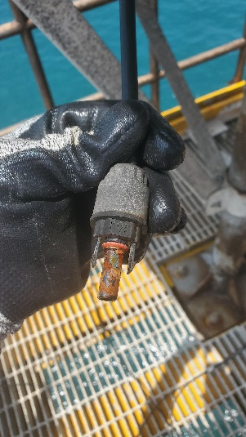 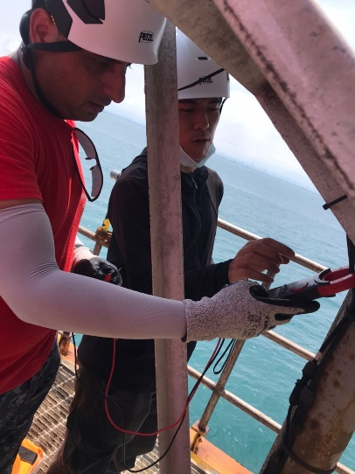 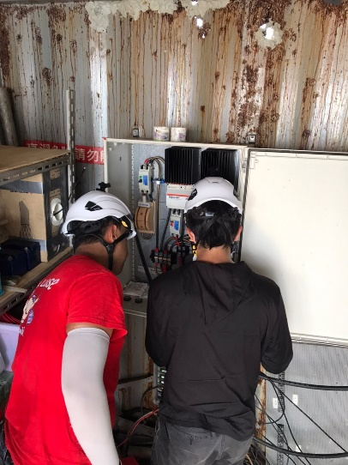
Solar cable joint corrosion /
Solar panel voltage and current output detection /
Solar charger detection
Installing guardrails (shaped steel) on the battery rack can effectively prevent the battery from being displaced due to earthquakes and other factors, which may lead to line breakage.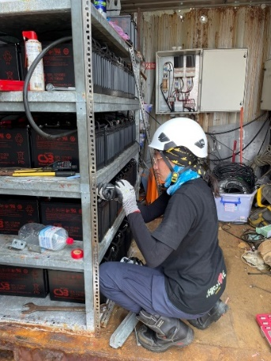 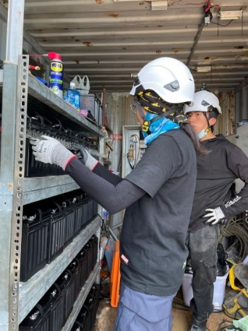 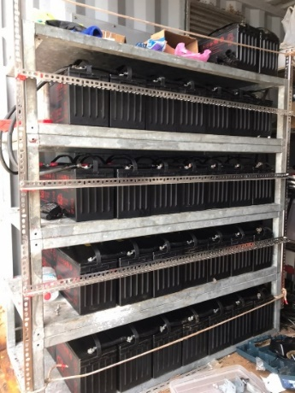
Battery rack installation steel work

Remove unused cables and organize cable troughs.
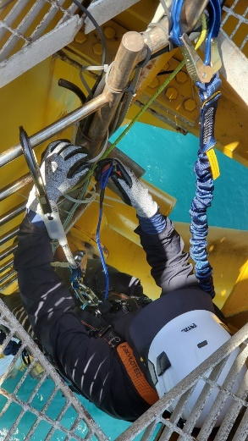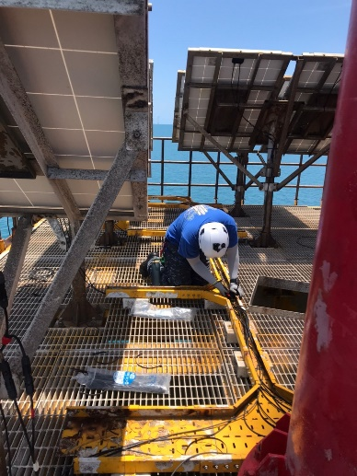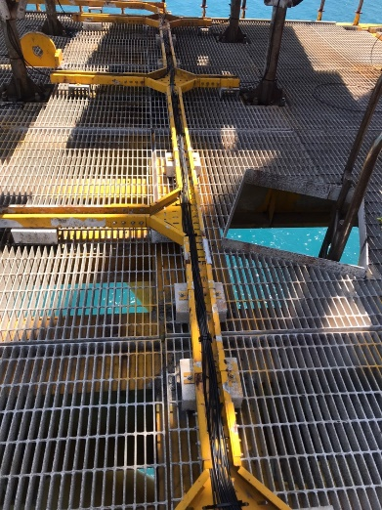
Before and after removing unused wires / organizing wires
Organize and clear tools on the tower and store them by type for later use.
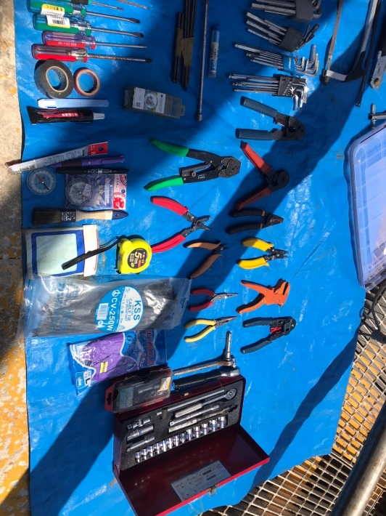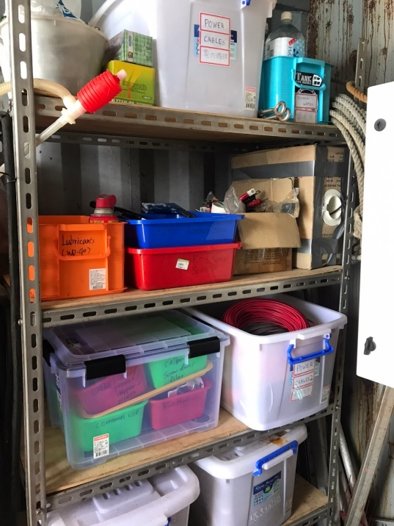
Clean up and organize various tools

After installing a new antenna on the Met Mast, a connection test was conducted. After testing, it was found that there was no way to successfully connect to the land-based equipment. Time will be arranged to go to the Hanbao Activity Center to check whether there is any abnormality with the equipment. After inspection, the reasons for the connection failure were found; the router was damaged, and the internal settings of the communication equipment on the land side and the weather tower side were inconsistent.

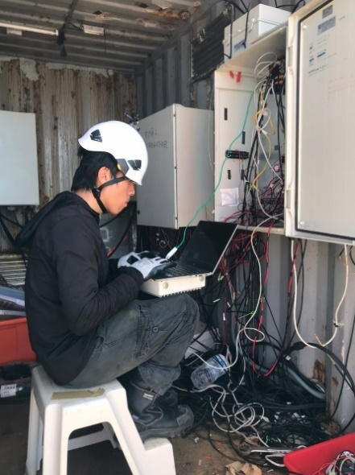
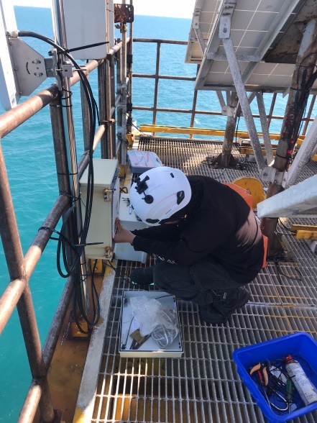
Communication equipment installation / Communication equipment testing
June 2022
Following the inspection of the energy storage system on the Fuhai Met Mast in March, it was found that the voltage value of the battery was too low to support system operation. The main purpose of this work was to replace the energy storage system with new batteries. Battery replacement also includes offshore lifting operations; the new battery is hoisted from the work ship to the meteorological observation tower platform, and the old battery is hoisted to the work ship at the same time.

After completing the hanging operation of the battery, the technician then proceeds to connect the battery of the energy storage system.。
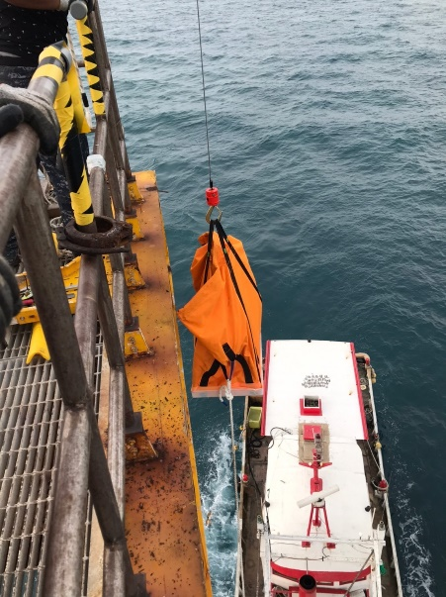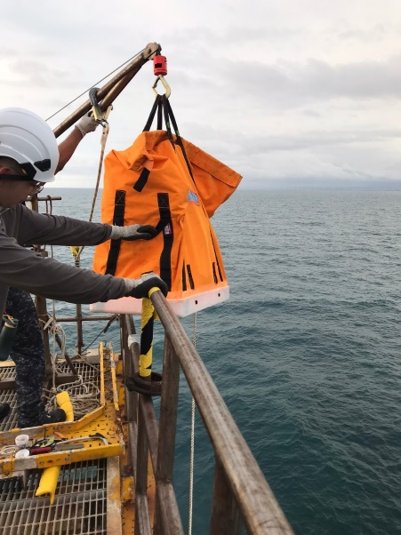
Use hanging bags to hang batteries
March 2022
After the renovation and maintenance of the Fuhai Met Mast was completed, it was the first time to climb the tower for maintenance operations. The main maintenance focus was on maintenance operations related to instruments and power systems. The technicians' main tasks this time were to replace new navigation warning lights, inspect solar panels and wind turbines, inspect the operation of the energy storage system, inspect the starting of the generator, and finally organize the storage space.

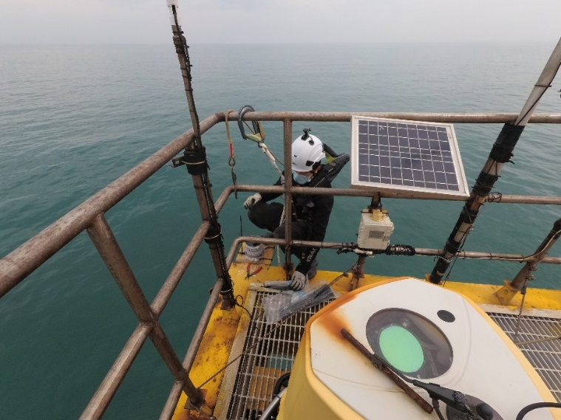

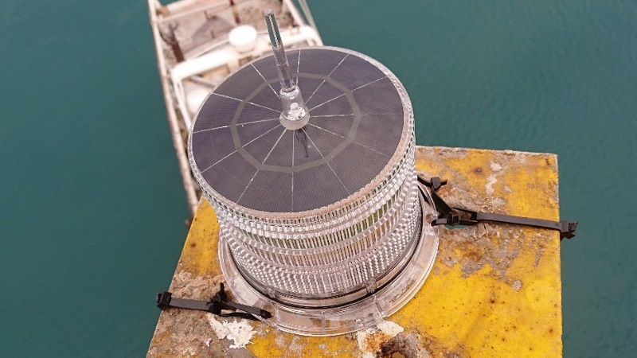
Marine warning light installation

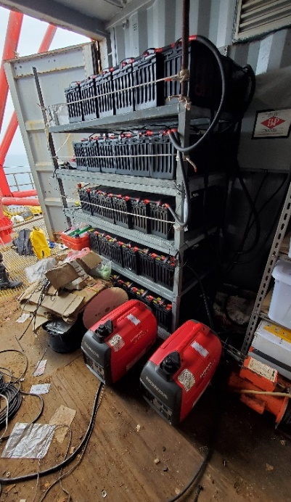
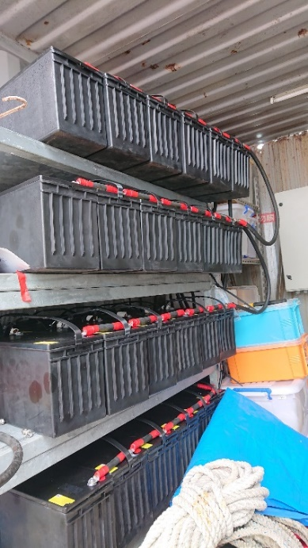

Before and after battery cleaning

