Fuhai Met Mast O&M record 2021

O&M Works in 2021
Due to the damage to the lower ladder structure, it was impossible to climb the tower for operation and maintenance.Therefore, a manufacturer was commissioned to cast new ladders and steel structures and perform anti-corrosion coating operations. The ladder structure can be installed after the coating operation is completed. After the installation is completed, the anti-corrosion coating treatment and surface painting of the structural connection points will be carried out.

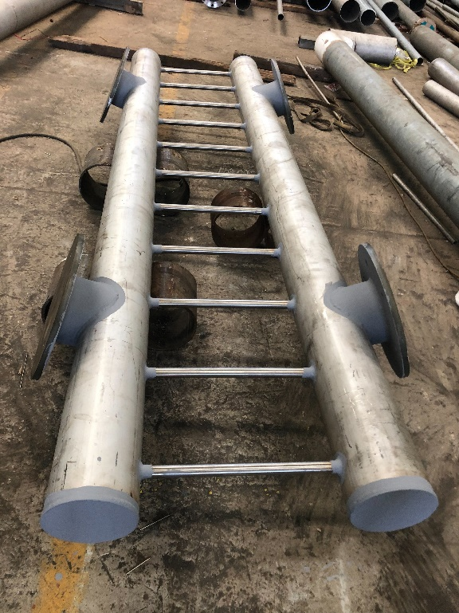
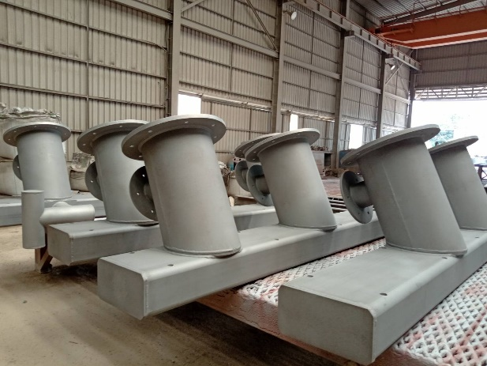
Ladder structure casting

Due to the ladder is to be installed in an offshore environment, anti-corrosion coating is required before installation.

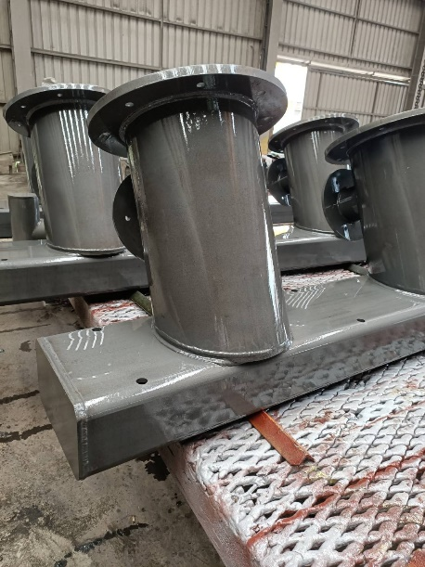
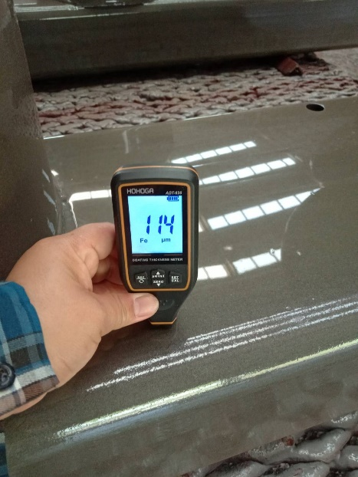
Primer is applied to the ladder structure, the quality manager confirms that the thickness of the primer does not meet the standard.

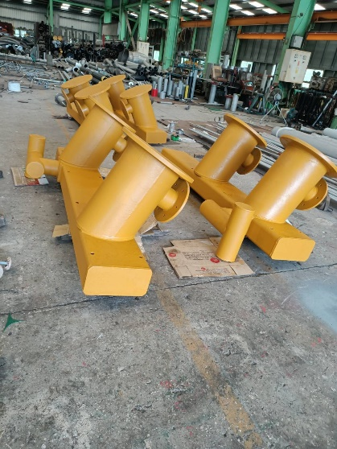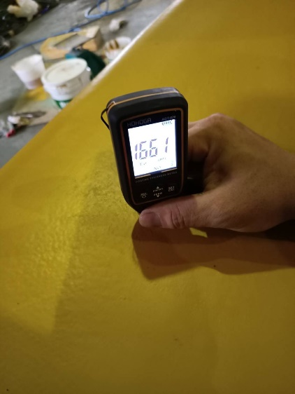
The ladder structure is top-coated, the quality manager confirms that the topcoat thickness does not meet the standard.

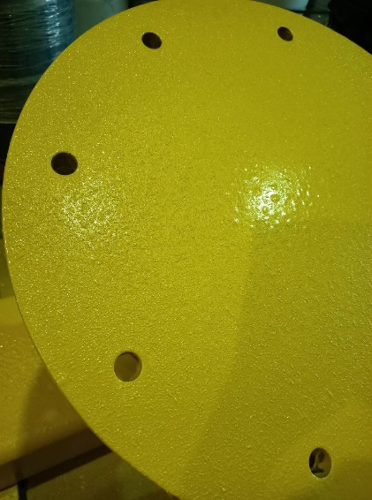 polyurea coating

After the anti-corrosion coating has dried, proceed with trial installation.
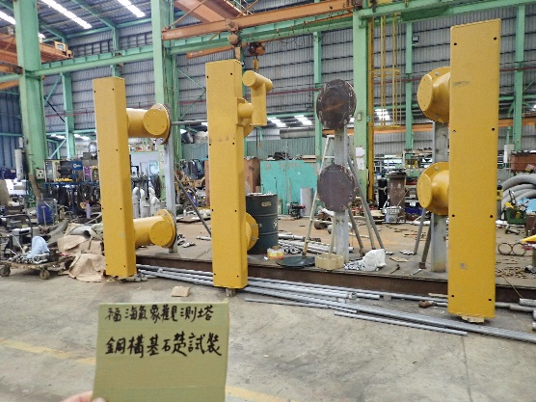 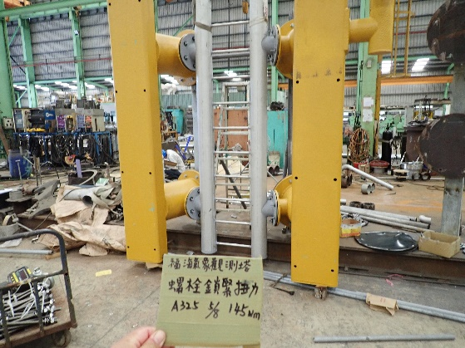

After installing the fender, conduct a test lifting and weight measurement.
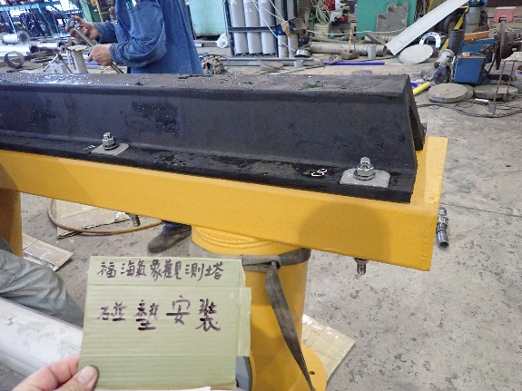 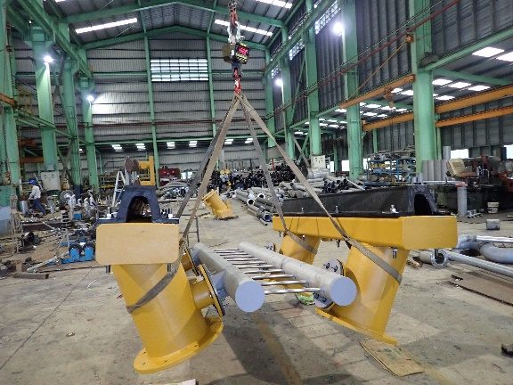

Before installing the new lower section of the ladder, paint and repair the steel structure.
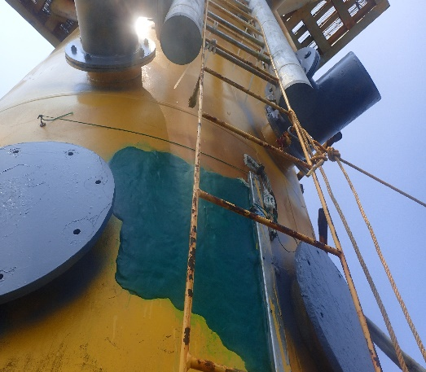 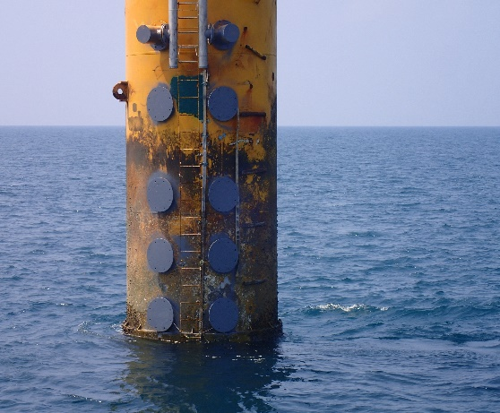

Post-installation patching
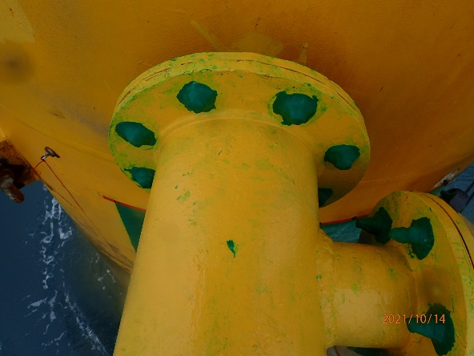 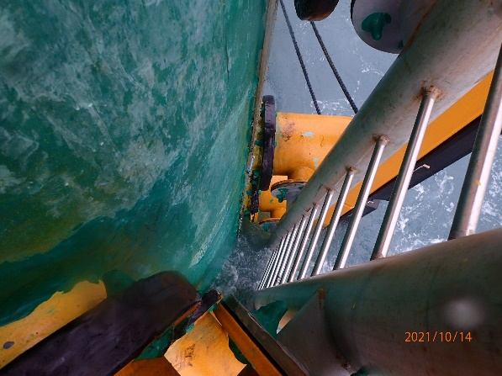
Anti-corrosion coating repair on steel structure joints and steel pile surfaces

Surface paint job at the finish site.
